*********** Pallavi N Rangaswmy*************
Candidate Current Location | Bangalore
Availability to Interview | Any Week Days
Date Available to Start | 5 Days
If previous Intel experience, please provide:
- Previous WWID if known
- Previous sponsor names if known
- Dates employed
- Engagement type (CW or FTE)
- Name used when employed at Intel
Please explain why you feel this candidate is best fit for this position / provide any additional comments | She has good experience in handling all admin activities whatever mentioned in the JD

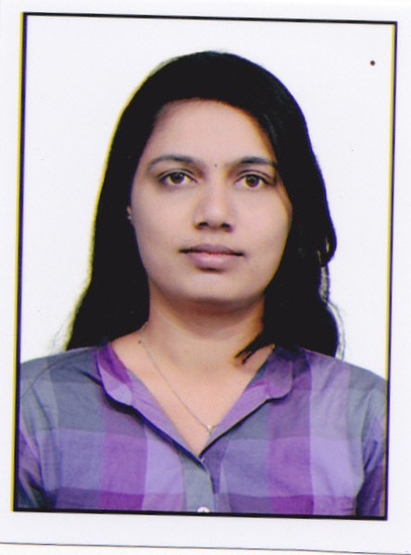
PERSONAL INFORMATION
Name: | Pallavi N Rangaswmy
Present Address: | #7,Vinayaka reddy Building,  Gare bavi playa, Bangalore: 560078.
Telephone: | +91-9036103234
E-mails: | pallavi.suri54@gmail.com
Nationality | Indian
Date of Birth: | 18/04/1989.

Objective:
Seeking an assignment in a fast growing Organisation.
Synopsis: Multifaceted and goal-oriented professional with valuable experience in Human Resource Management including experience in employee recruitment and retention, staff development, conflict resolution, rewards and recognition, benefits and compensation, HR records management and HR policies development. Highly organized and detailed adept at providing administrative direction and office operational strategies critical to organizational success with proven ability to thrive in busy environment with positive results. Well-developed interpersonal skills coupled with outstanding verbal and written communication skills, able to establish and maintain productive relationships across all organizational levels seeks an exposure in Corporate firms.

Professional Competencies:
Human Resource Management
- Manpower recruitment and selection.
- Arranging new employee orientation.
- Performance Management: Appraisals and promotion.
- Resource mobilization, motivation and training.
- Organizing professional development courses..
- Performance appraisal.
- Developing human relationship and subordinate development.

Administration
- Managing general administration and Security management.
- Management of facilities
- Travel manegement.
- Event management.
- Manages and maintains the office, including monitoring and ordering stationery needs.
- Vendor Management.
- Attendance and salary payroll.
- Supervised and monitored staff activity, working conditions.
- Prepared consolidated administration related reports.
- Assisted in preparation of budget.
- Documentation work.
- Handled complex administration tasks.
- Managed all complicated duties of organization.

Corporate Relations
- Maintaining cordial management-employee relations.
- Developing and Manging relations with new Business Partners.
- Handling staff welfare activities.
- Quick resolution of employee grievances.

Experience Details:

Overall experience of 2.7 Years in HR & Administration
- September, 2013 – 10, April, 2014
Yensys Technologies, Bangalore
HR Admin

- Handling Time Office and maintenance of attendance & leave records.
- payroll management.
- Managing and handling billing of the vendors.
- Working on purchase order, bill payment.
- Transportation in charge
- Updating & maintaining Employee data base.
- Bank Account opening procedures for all employees.
- Purchase and Price negotiation.
- Security Management,housekeeping management,Asset management
- Issue of ID & Visiting cards to all employees.
- Air ticket booking ,Manage transport requirements of employees.
- Courier management.
- Manage internal filing systems and documents.
- Facility management.
- Handling petty cash, order Stationary, housekeeping items etc .
- Doing background checks and verifying the references, work experience and academic qualifications of applicants.
- Day-to-day interviews and managing internal and external job postings, Exit Interview and feedback.
- Maintain trainee-tracking Excel-database and produce monthly training report and calendar.
- Issue the appointment, renewal & confirmation, warning letters.
- Ensuring Birthday celebration and holiday list.
- Joining formality & maintain employees document.
- Full & Final settlement of an employee during exit.
- Exit Interview and feedback.

Experience Details:
- July, 2011 – August 2013
Ina India Ltd, Bangalore
HR Admin

- Prepare Invoice, Purchase Order, Sales entry, Purchase entry in Tally.
- Issuing offer letters and appointment letters to new employees.
- Standardized the joining formalities process of new employees(Welcome circular, Introduction, Stationary, Bank Account, Reference check, Time Sheet etc)
- Celebrating various events like (Employees Birthday, Outdoor trips etc.)
- Maintain courier register.
- Keeping records of employee's status change i.e. Confirmation, Probation.
- Maintain Appraisal Details (Half Day, Leave day, late days, productivity etc.) and forwarding it to the HOD for the further procedure.
- Uniform distribution and maintain record.
- Attendance records leave records, OT records, and monthly payroll processing.
- Travel service provider, hotel rates, taxi/transport for services
Flight bookings, train booking, maintain travel plans.
- Handling petty cash, bill payments.
- Maintain Housekeeping, stationary, Electrical related work, Carpenter related work and Organizing parties and Functions.
- Assists office staff in maintaining files and databases.
- Prepares reports, presentations, memorandums, proposals and correspondence.
- Monitors office operations.
- Tracks office supply inventory and approves supply orders
- Handling Corporate Vodafone Mobiles, credit card bill for MD, New Connections & Payments.
- Execution of welfare activities such as Canteen, Transportation, Security etc
- Recruitment part, Monitoring Contractors Statutory records Like ESI, PF & Various returns & registers.
- As per Factories act Maintaining the register like Advance register, over time register, register of Fines, Accident register.
- Preparation & submission of all statutory returns monthly & annually.
- Handling Employee Full & Final settlement.
- Monitoring Employee Absent sum sending Notice to the Absentees
- Tracking Employee Loan, Advance records.
- Verify all kind all kind of service bills like courier bills, water bills, Internet bills, travel bills, canteen bills.
- Handling Vehicle Insurance renewal.
- Stock maintains, daily prepare stock report.
- Prepare agreement letter & other letters.
- Vendor management.
- Stock import & export management, E-sugam and C form submit and update.
- Fallow up the collection.
- Arrange medical allowance.

Educational Qualification:
- 2011 BBM Women’s College, Hassan.
- 2008 PUC AVK College, Hassan.
- SSLC St Philomina’s School Hassan.

Computer Knowlwdge:
- Proficient in Tally 7.2 & 9.0
- Good at MS Word, MS Excel, Power Point,(Internet, E-mailing)
- Junior typing.

Personal Details:
Name : Pallavi N R.
Fathers Name : Late S Rangaswmy
Date of Birth : 18-04-1989
Languages Known : English, Kannada, telgu & Hindi.
Nationality : Indian.

